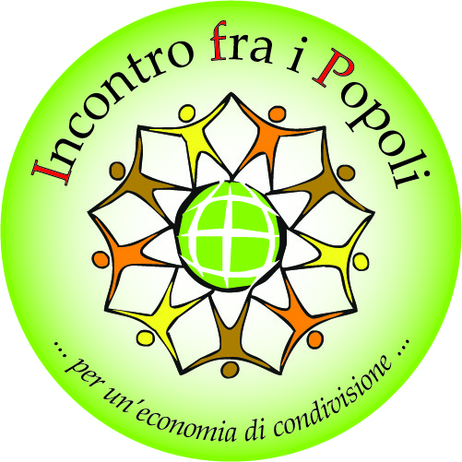

To candidates interns and trainees at “Incontro fra i Popoli”
Dear student,
we are very happy to welcome your interest in doing an internship with “Incontro fra i Popoli” .
If you have to write your university dissertation, you may want to visit our website www.incontrofraipopoli.it You will find a list of ‘dissertations in search of authors’. If you don’t find anything you like, we will discuss other topics together when we will meet.
Our office is located in Cittadella (Padova). If you come from far away you can stay in our guest house (we ask for a minimum contribution of € 5 per night).
Here are some conditions we put together to match your expectations:
- We will provide you with knowledge, experiences, means, instruments and time dedicated to you.
- We expect you to offer us knowledge, insights and time, always preserving:
- Humility: our association and members of “Incontro fra i Popoli” have a strong life experience, which motivates choices and paths which the ones just arrived do not always understand.
- Availability : everyone is able to accomplish any kind of task and we all do that with different roles. For this reason some takes are done by interns like you; you may think these seem to be secondary. However, for new people like you, they are very important.
- Volunteering: our association is based on volunteering, which includes passion and not-paid work. For this reason we ask you not to limit your contribution to “Incontro fra i Popoli” at the minimum amount of hours required by your internship.
- Flexible working hours : we try to match your expectations but you also have to try to match ours (sometimes we will ask you to work on evenings, Saturdays, or Sundays).
- Aspecificity: even if you are interested in one specific area of our work, we ask you to approach a little bit all of them, in order to get a clear and complete idea of our work, and to discover your potential.
- Don’t ask us to manage your relation with the university/institution requesting your internship. Bureaucratic aspects are up to you, but we can help you to fill the documents, if needed.
- When you are here at “Incontro fra I Popoli” you will need to discuss with an internal tutor your job, either orally or through a written diary. The tutor will be your guide and will work to make your time with us a strong human, professional, and socially useful experience.
- At the end of your internship we will ask you to write a descriptive report to publish in our website and in our newspaper.
- If your dissertation focuses on issues relating to “Incontro fra i Popoli” at the end of your internship we will be glad to have a copy of that.
Now that you have clear information, if you still want to do an internship with our association, please send us by e-mail your written request (directly in the email and not in an attached document) following this format:
- Name, surname, year of birth, languages you know, mobile phone number, nationality, residential address, home address (if it is different from the residential), higher qualification, course or master you are attending, name of the university you are enrolled in, length of the internship you request.
- Your presentation (max 10 lines).
- Description of what you would like to do and your expectations (max 10 lines).
Once received your email, Leopoldo Rebellato, responsible of sector “cultural exchanges”, will call you to arrange a meeting with him at our office in Cittadella.
During the meeting with Leopoldo, you will be able to understand if your request have been accepted and when you can start your internship.
If you want others information please don’t hesitate to call: +39 049 597 53 38.
We look forward to hearing from you soon,
Michele Guidolin Director

